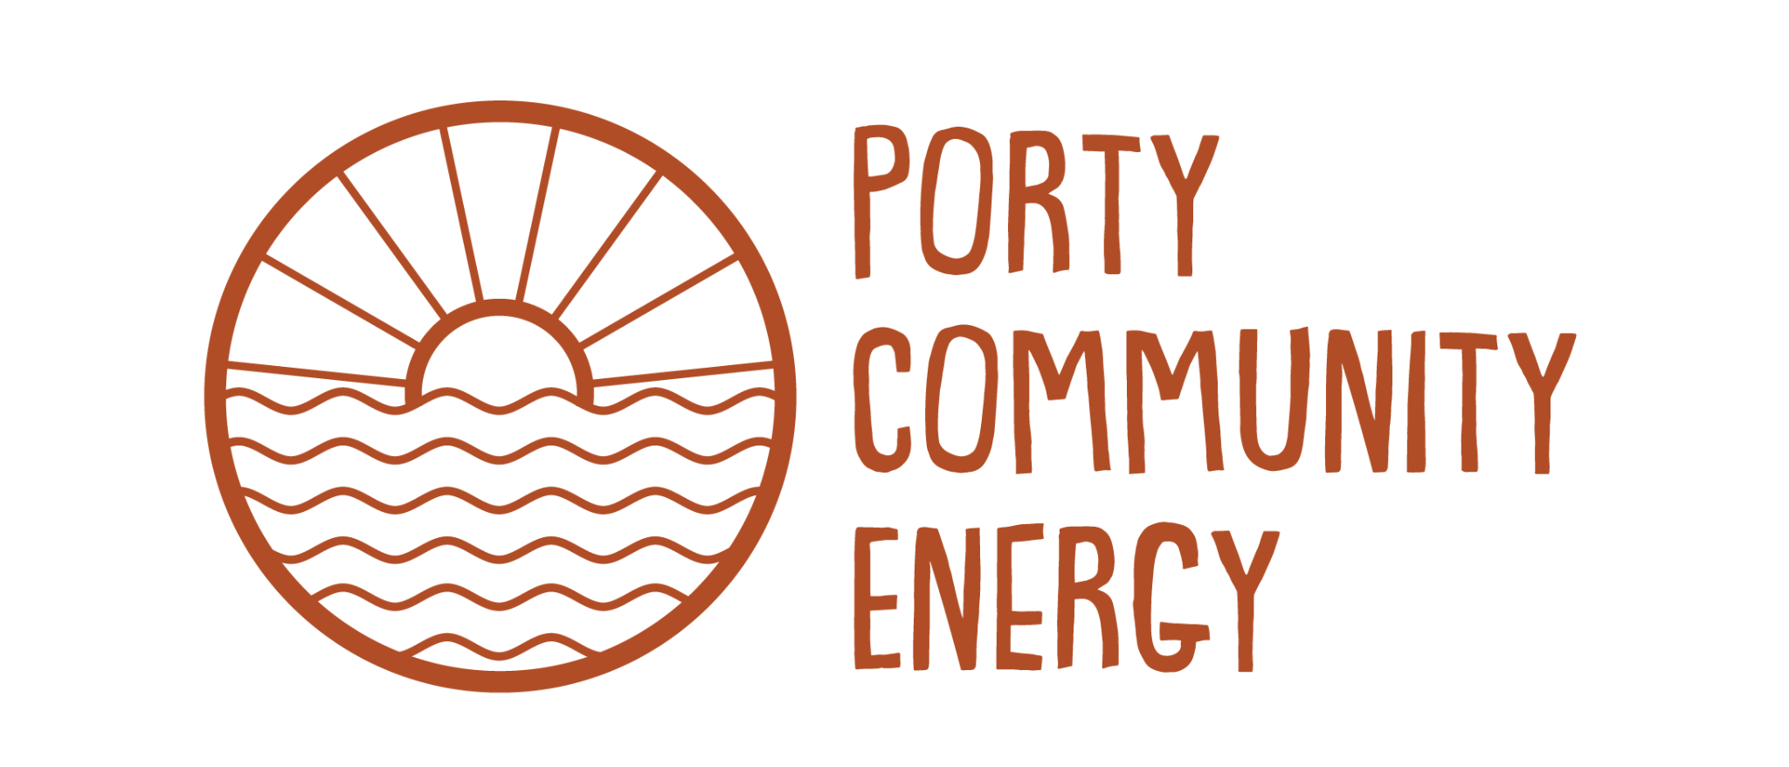

Porty Community Energy
Monitoring Equal Opportunities – job applications

We are committed to building a diverse, inclusive and welcoming organisation. As part of this commitment, we aim to eliminate discrimination in our recruitment processes and ensure that everyone has an equal opportunity to apply for roles at Porty Community Energy.

To help us monitor the effectiveness of our recruitment practices and meet our responsibilities under equality legislation, we collect and analyse information provided in this form.

How to fill in the form
Please complete this form by selecting the responses that best describe you. You only need to provide the information you feel comfortable sharing.
The information you provide will be kept confidential, stored securely, and separated from your application before shortlisting takes place. It will be used for monitoring purposes only and will have no influence on the recruitment or selection process.

Data Protection
The information collected in this form will be used solely for equal opportunities monitoring. It will be processed in accordance with data protection legislation, stored securely and treated as strictly confidential. Only authorised individuals involved in monitoring equality and diversity information will have access to this data.

Equality and Diversity Monitoring Form

Age

Please tell us your age in years:

Gender
Male ☐ Female ☐ Non-binary ☐ Transgender ☐

Disability Note: Under the Equality Act 2010 a disability is described as a physical or mental impairment that has a substantial and long term adverse effect on a person’s ability to carry out normal day-to-day activities.
Do you consider yourself to have a disability? Yes ☐ No ☐
Ethnicity  White  White Scottish ☐  White British ☐  White Irish ☐  White other ☐  Asia, Asian Scottish, Asian British  Indian ☐  Pakistani ☐  Bangladeshi ☐  Chinese ☐  Any other Asian background, please write here: | Black, Black Scottish, Black British  Caribbean ☐  African ☐  Any other Black background, please write here: ______________________________  Mixed  Any other mixed background, please write here:_______________________________  Other  Other ethnic background, please write here: __________________________________
Religion, religious belief or similar philosophical belief  Do you identify with any of the following belief systems?  None ☐  Church of Scotland ☐  Roman Catholic ☐  Other Christian ☐  Buddhist ☐ | Hindu ☐  Muslim ☐  Jewish ☐  Sikh ☐  Other Religion: ______________________  I choose not to disclose ☐

Sexual Orientation
Heterosexual ☐
Gay man / Homosexual Man ☐
Lesbian / Homosexual Woman / Gay Woman ☐
Bisexual ☐
Choose not to disclose ☐

Comments
I choose not to complete the Form ☐ | Date:

